Software Design Specification

Revision History
Rev | Date | Revision History
00 | 2025.02.28 | First Issued.

Contents
1. Scope and Purpose 7
1.1 Purpose 7
1.2 Scope 7
1.3 Software Identification 7
1.4 Reference 7
2 H/W, S/W architecture 8
2.1 Hardware architecture 8
2.2 Software architecture 9
3. Software Design specification 10
3.1 Design specifications for software architecture 10

1. Scope and Purpose

1.1 Purpose
This document provides a description of the software design.

1.2 Scope
The SDS document applies only to the software design of the MCU. It does not include hardware design.

1.3 Software Identification
Software name | FasterDx
Software version | 1.00.00
Operating system | Windows 10 IoT Ent.
Programmable language | C++, C#
Safety Level | Class B

1.4 Reference
Reference | Title of standard
1) ISO 14971 [2019] | Medical devices –Application of risk management to medical devices.
2) IEC 60601-1 [2005]+AM1[2012] | Medical electrical equipment – General requirements for basic safety and essential performance
3) IEC 60601-1-2 [2014] | Medical electrical equipment. General requirements for basic safety and essential performance. Collateral Standard. Electromagnetic disturbances. Requirements and tests.
4) ISO 7010:2011 | Graphical symbols -- Safety colours and safety signs -- Registered safety signs
5) IEC 60601-1-6 [2010]+AMD1[2013] | Medical Electrical Equipment - Part 1-6: General Requirements for Basic Safety and Essential Performance - Collateral Standard: Usability
6) IEC 62366 Ed. 1.0 [2007] +AMD1[2014] | Medical devices - Application of usability engineering to medical devices
7) Medical Device Act, Enforcement Rules of the Medical Device Act | Provisions delegated by the Medical Device Act and its Enforcement Decree, as well as necessary matters for their implementation.
8) Medical Device Manufacturing and Quality Management Standards | Establishes the necessary details to be followed in manufacturing or importing, as well as the designation procedures and management methods for quality management auditing institutions and training institutions for quality managers.

2 H/W, S/W architecture

2.1 Hardware architecture
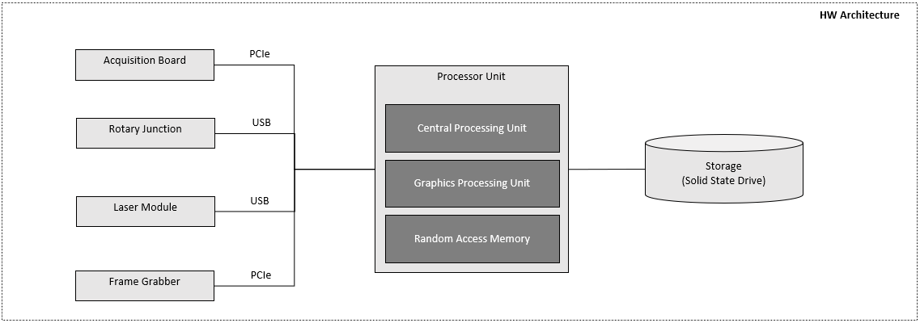

2.2 Software architecture
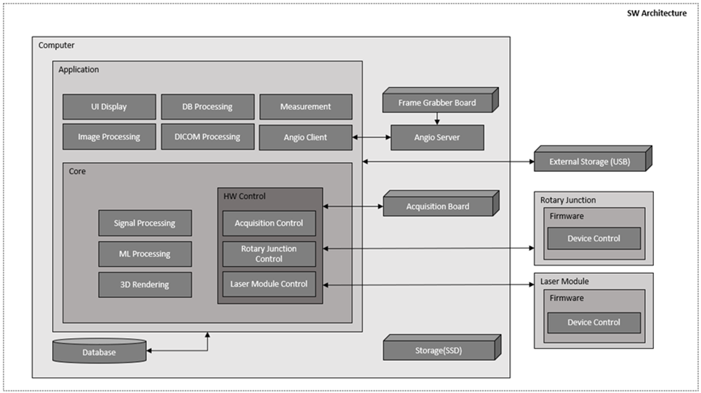

3. Software Design specification
The software safety class is initially assigned based on the following severity levels and is applied to the development process accordingly.

Class A | No injury or damage to health is possible
Class B | Non-serious injury to possible
Class C | Death or serious injury is possible

- The SDS (Software Design Specification) is determined by considering the following factors.
1) allocation of RISK CONTROL measures to subsystems and components (sensors, actuators, PESS and interfaces.) of the PEMS.
2) failure modes of components and their effects
3) common cause failures
4) systematic failures
5) test interval duration and diagnostic coverage
6) maintainability
7) protection from reasonably foreseeable misuse
8) the NETWORK/DATA Coupling specification, if applicable

- The SDS (Software Design Specification) should be designed by applying the following considerations.
a) Components With High integrity Characteristics
b) failsafe functions
c) redundancy
d) diversity
e) partitioning of functionality
f) defensive design, e.g. limits on potentially hazardous effects by restricting the available output power or by introducing means to limit the travel of actuators.

3.1 Design specifications for software architecture
Refer to RW-TF-FST-02-06(00) Attachment SDS List.

